COMP3023 Design and Analysis of Algorithms
Spring 2026
Assignment 2

Given the following weighted simple undirected graph $G=(V,E)$, answer Question 1-3. If there are multiple choices, follow the alphabetical order. For example, the edge $(a,g)$ goes before the edge $(b,c)$ because $a<b$ in alphabet.
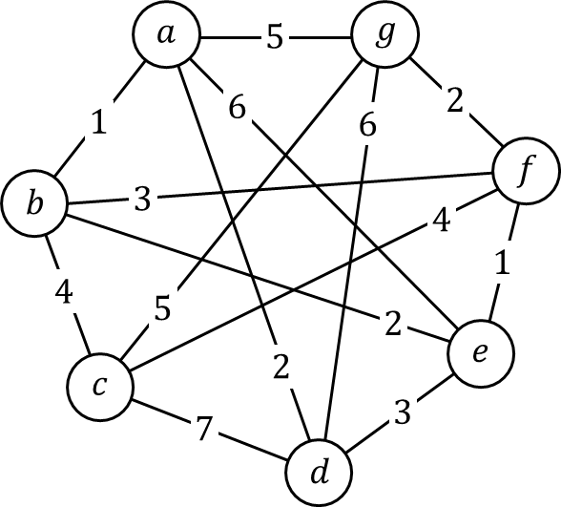
Question 1.
Show the execution of Prim’s algorithm to find the minimum spanning tree. In each step of the execution, you need to draw one graph to show the cut, the edges crossing the cut, and the light edge. You also need to build a table for each step to show $key[v]$, $pred[v]$ and the priority queue. Suppose the algorithm starts from vertex $d$.

Question 2.
Show the execution of Kruskal’s algorithm to find the minimum spanning tree. In each step of the execution, you need to show the selected edge and the result of up tree (union find data structure) structure union by height. If there are multiple choices for the root, the alphabetically smaller vertex is the new root.

Question 3.
Show the execution of Dijkstra’s algorithm to find the shortest path from vertex $f$. You need to build a table to show the selected vertex, $d[v]$, $color[v]$ and $pred[v]$ for each step of the execution.

Question 4.
Is a minimum spanning tree a shortest path tree? Is a shortest path tree a minimum spanning tree? Prove your answer.

Question 5.
Given a list of $n$ tasks $T=(t_{1},t_{2},⋯,t_{n})$, a single task $t_{i}$ is accomplished by a cost $c_{i}$ and has two prerequisite lists of tasks $con[t_{i}]$ and $dis[t_{i}]$. Before doing task $t_{i}$, one must have finished all tasks in $con[t_{i}]$ and at least one task in $dis[t_{i}]$. We defined $cost(t_{i})$ be the total cost to finish $t_{i}$ and all tasks needed to be finished before $t_{i}$.
Sometimes $t_{i}$ is unsolvable if there is a deadlock. A deadlock happens if there is a sequence of tasks $t_{1}^{'},t_{2}^{'},⋯,t_{m}^{'}$ such that $t_{m}^{'}$ is the prerequisite of $t_{1}^{'}$ and $t_{i-1}^{'}$ is the prerequisite of $t_{i}^{'}$ (no matter $con[t_{i}^{'}]$ or $dis[t_{i}^{'}]$) for $1<i≤m$.
Design an algorithm to find the minimum cost to finish a given task. You need to formally model the problem using a graph. You need to precisely define the input and the output, describe your algorithm on a high level, present your algorithm by pseudo codes, and analyze the time complexity.

